Docker provides tooling and a platform to manage the lifecycle of your containers:

* Develop your application and its supporting components using containers.
* The container becomes the unit for distributing and testing your application.
* When you’re ready, deploy your application into your production environment, as a container or an orchestrated service. This works the same whether your production environment is a local data center, a cloud provider, or a hybrid of the two.

Docker Engine

*Docker Engine* is a client-server application with these major components:

* A server which is a type of long-running program called a daemon process (the dockerd command).
* A REST API which specifies interfaces that programs can use to talk to the daemon and instruct it what to do.
* A command line interface (CLI) client (the docker command).

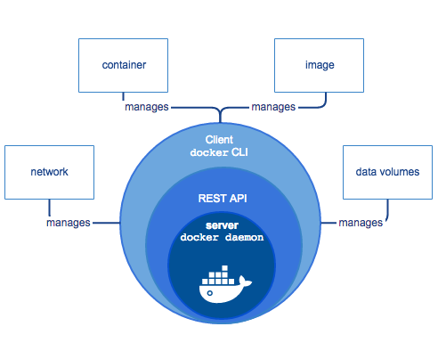

The CLI uses the Docker REST API to control or interact with the Docker daemon through scripting or direct CLI commands. Many other Docker applications use the underlying API and CLI.

The daemon creates and manages Docker *objects*, such as images, containers, networks, and volumes.

**Note**: Docker is licensed under the open source Apache 2.0 license.

For more details, see [Docker Architecture](https://docs.docker.com/engine/docker-overview/#docker-architecture) below.

What can I use Docker for?

**Fast, consistent delivery of your applications**

Docker streamlines the development lifecycle by allowing developers to work in standardized environments using local containers which provide your applications and services. Containers are great for continuous integration and continuous delivery (CI/CD) workflows.

Consider the following example scenario:

* Your developers write code locally and share their work with their colleagues using Docker containers.
* They use Docker to push their applications into a test environment and execute automated and manual tests.
* When developers find bugs, they can fix them in the development environment and redeploy them to the test environment for testing and validation.
* When testing is complete, getting the fix to the customer is as simple as pushing the updated image to the production environment.

**Responsive deployment and scaling**

Docker’s container-based platform allows for highly portable workloads. Docker containers can run on a developer’s local laptop, on physical or virtual machines in a data center, on cloud providers, or in a mixture of environments.

Docker’s portability and lightweight nature also make it easy to dynamically manage workloads, scaling up or tearing down applications and services as business needs dictate, in near real time.

**Running more workloads on the same hardware**

Docker is lightweight and fast. It provides a viable, cost-effective alternative to hypervisor-based virtual machines, so you can use more of your compute capacity to achieve your business goals. Docker is perfect for high density environments and for small and medium deployments where you need to do more with fewer resources.

Docker architecture

Docker uses a client-server architecture. The Docker *client* talks to the Docker *daemon*, which does the heavy lifting of building, running, and distributing your Docker containers. The Docker client and daemon *can* run on the same system, or you can connect a Docker client to a remote Docker daemon. The Docker client and daemon communicate using a REST API, over UNIX sockets or a network interface.